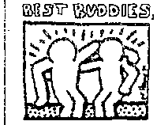
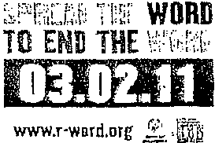
Special

Olympics
Be a fan.

Spread the Word to End the Word

It is time we Spread the Word to End the Word and build awareness for society to stop and think about its use of the R-word. That R-word is something hurtful and painful- "retard" or "retarded." Most people don't think of this word as hate speech, but that's exactly what it feels like to millions of people with intellectual and developmental disabilities, their families and friends. The R-word is just as cruel and offensive as any other slur. Visit www.r-word.org to make your pledge today.

• Young people around the world are taking a stand and raising awareness of the dehumanizing and hurtful effects of the words "retard" or "retarded" and are helping encourage others to think before they speak.

• We ask that you help us change the conversation and help eliminate the demeaning use of the R­ word from today's popular youth vernacular and replace it with "respect." We are asking for your help in creating a more accepting world for people with intellectual and developmental disabilities and all those people that may appear different, but have unique gifts and talents to share with the world.

• We're asking every person - young and old -to help eliminate the demeaning use of the R-word­ a common taunt used to make fun of others. Often unwittingly, the word is used to denote behavior that is clumsy, hapless, and even hopeless. But whether intentional or not, the word conjures up a painful stereotype of people with intellectual and developmental disabilities. It hurts. Even if you don't mean it that way.

• People with intellectual and developmental disabilities are capable and enjoy sharing life experiences -listening to music, playing video games, watching the latest movies, and yes, • having fun -as well as working together toward athletic excellence and mutually enriching one­ to-one friendships as demonstrated constantly through Special Olympics and Best Buddies International. They can attend school, work, drive cars, get married, participate in decisions that affect them, and contribute to society in many ways.

• Did you know that by casually using the word "retard(ed)" to refer to an action as less than ideal you are making someone with an intellectual disability feel less than human -whether you mean to or not? Demeaning any of our fellow human beings by using inappropriate words toward any population negatively impacts all of us.

• Today the r-word has become a common word used by society as an insult for someone or something stupid. For example, you might hear someone say, "That is so retarded" or "Don't be such a retard." When used in this way, the r-word can apply to anyone or anything, and is not specific to someone with a disability. But, even when the r-word is not said to harm someone with a disability, it is hurtful.

Do your part and ... Spread the Word to End the Word

Please read the article and write a ½ page response answering the following questions:

- Have you ever used the words “retard” and “retarded” when talking to someone else?
- How do you think calling someone “retarded” would make them feel if they knew they had an intellectual or developmental disability?
- How can you help to stop the use of these words in your home, school, community?

